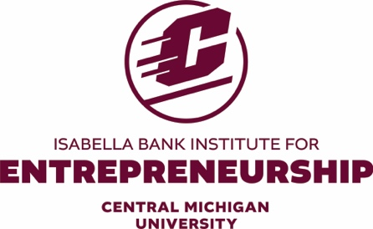

Entrepreneurship Faculty Fellows Program

Purpose: To recognize faculty that apply and develop expertise in co-curricular settings and for their support of students through guidance and participating in programs & events that elevate student entrepreneurs, such as the New Venture Competition (NVC).
Goals:
- Increase number of faculty mentors & advisors
- Broaden range of skills and experiences of faculty mentors available to help students
- Provide options for both advising and mentoring opportunities that best fit faculty expertise and interest
- Create incentives for faculty to prioritize and invest their time in this program

Award Design and Requirements:
- Awarded annually based on contributions/time

- CBA Deans Office will award $1,000 of professional development funds to CBA faculty achieving this designations

- Subject to approval of the faculty’s Dean, CBA Dean’s office will award $1,000 of professional development funds to non-CBA faculty achieving this designation

- Qualification requires~ 50 hours of contribution

NVC Faculty Fellows Program Requirements

Advising Opportunities- contribute in established NVC programs, workshops and special events along with being an advisor to multiple student venture teams at workshops and other times as appropriate/needed. Approximately 50 hours may be achieved advising alone, or in combination with mentorship.
Attend several from the following events (2023/24 dates):

- NVC Kick-off & Ideation – 2 hrs
- Fall Bootcamps 1 and 2 – 4 hrs each
- Fall Workshops – up to 4 hours
- Global Entrepreneurship Week (GEW) events – up to 4 hrs
- Pitch Prep – 2 hrs
- Moderate/participate in Make-A-Pitch – 4 hrs
- Guidance and support at various IBIE events & speakers – up to 4 hours
- NVC Spring Kickoff – 2 hrs
- Spring Bootcamps 3 & 4 – 4 hrs each
- Spring Workshops – up to 4 hours
- Spring Hackathon – up to 12 hrs
- Other Spring prep and mentoring sessions – up to 6 hrs
- Moderator/participate in April NVC event – up to 12 hrs
Total hours available 72

Mentorship Opportunities - contribute in selected NVC programs, workshops and special events along with being a mentor for student venture teams. Approximately 50 hours may be achieved mentoring alone, or in combination with advising.
" Attend selected events (from above list) to achieve minimum of 25 hours
" Mentoring student teams typically requiring 1-2 hours per week, starting as early as October and especially during the Spring semester (J-F-M-A) leading up to the mid-April NVC event. Total expected hours 25.

Note: This program may align to Section F.3 regarding maintenance of AACSB IP Status, subject to approval of your administration.
Additional details of the commitment involved are available from Julie Messing, Director of the Entrepreneurship Institute. julie.messing@cmich.edu

