**Applied Statistics – Part I**

**Qualifying Exam - January 2017**

**Problem 1:**

Consider the following SAS output.

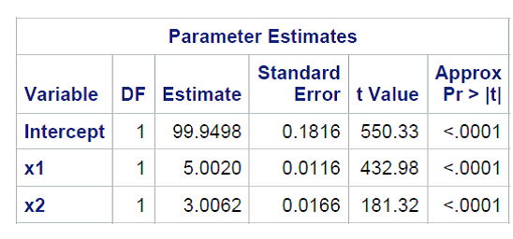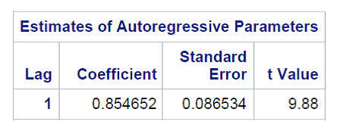

1. Write down the model.
2. Estimate β1 with 95% confidence interval.
3. When *n* = 41, X1 is expected to be 15 and X2 is expected to be 5. Obtain a forecast of the response when *n* = 41. Below are the first and last lines of the output printout:

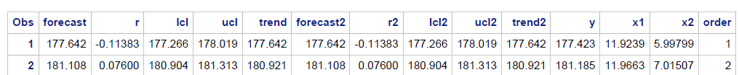

.

.

. 

**Problem 2**

1. Sketch a plot the exponential response function:
   1. *f(x*) = *100 -* (*1+x*) */ x2; x ≥ 0*
2. What is the asymptote of this response function?
3. For what value of *x* does the response function reach 95 percent of its asymptote?

**Problem 3**

Consider the following SAS output:

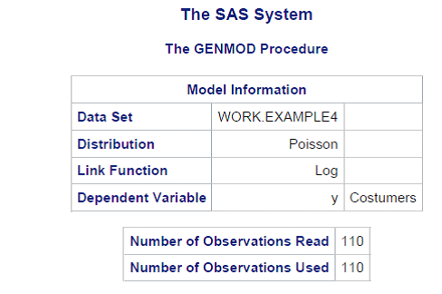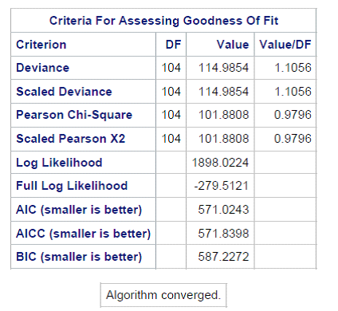

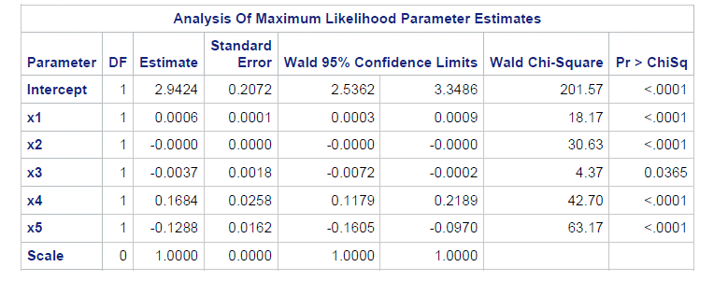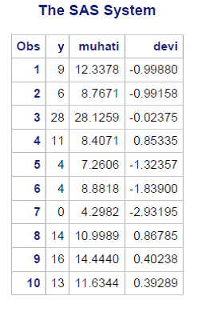

1. Write down the model.
2. Conduct an appropriate goodness-of-fit test. State the null, alternative, decision rule and conclusion.

**Problem 4**

In a two-factor study, the treatment means *μij are* as follows:

|  |  |
| --- | --- |
| Factor B | |
| Factor A | B1 B2 B3 |
| A1  A2  A3 | 151 166 169  189 174 171  170 170 170 |

1. Obtain the factor *A* level means.
2. Obtain the main effects of factor *A.*
3. Obtain the factor *B* level means.
4. Obtain the main effects of factor *B.*
5. Prepare a treatment means plot and determine whether the two factors interact.
   1. Assume that *σ* = 4 and *n* = 20.
6. Obtain *E{MSE}* and *E{MSA}.*
7. Is *E*(*MSA*)substantially larger than *E*(*MSE*)*?* What is the implication of this?

**Problem 5**

Consider the following linear combinations of interest in a single-factor study involving four factor levels:

(i) μ1 + *3* μ2- *4* μ3

(ii) .3μ1 + *.5* μ2 + *.1* μ3+ *.1* μ4

(iii) (μ1 + *3* μ2- *4* μ3)/3 - μ4

1. Which of the linear combinations are contrasts? State the coefficients for each of the contrasts.
2. Give an unbiased estimator for each of the linear combinations. Also give the estimated variance of each estimator assuming that *ni=n.*